**[](http://www.opencimi.org/)[](http://www.hl7.org/index.cfm)Recommended Information Model Integration**

HL7/ISO “Common Logical Information Model (CLIM)”

**Executive-Summary Final-Report**

Keith Campbell, Stan Huff, Julia Skapik, Steve Wagner

Nona Hall, Steve Hufnagel

September 15, 2016 (Sept 11, 2016 DRAFT)

**REQUESTED ACTION:** Send suggested improvements to [SHufnagel@apprioinc.org](mailto:SHufnagel@apprioinc.org)

See the August 15, 2016 Preliminary Report (80 pages) for details

Contents

1) Introduction: 1

*2)* Executive Summary 2

3) Background and Approach 4

4) Recommended Pilot Project Path 9

5) Contributions by Resource 9

a) Clinical Information Model Initiative (CIMI) 10

b) Federal Health Information Model (FHIM) 11

c) SNOMED, LOINC, RXNorm (SOLOR) 12

d) Clinical Quality Framework (CQF) and Standards Quality Improvement 13

6) Operational Architecture 15

7) Way Forward Attributes of Success 18

8) Initial Work Breakdown Structure (see MS Project version at end for details) 18

9) Stakeholders: Collaboration that Grows with Strong SME Base 19

10) Index of Acronyms 19

11) Work Breakdown Structure (WBS) 21

This DRAFT WBS is under development. 21

## Introduction:

* 1. **Report Influences**

This Report’s scope is Information Model Integration[1] based on:

* + 1. The CIMI- sponsored HL7 Investigative Study beginning in January 2016
    2. The CIMI- sponsored Task Force beginning in March 2016
    3. Federal Health Architecture (FHA) brief on FHIM Value in June 2016.
    4. The Technical Forum for Information Model SMEs in August 2016
    5. FHA Managing Board meeting on September 7, 2016.
    6. Modelling-SME discussions prior-to/during the HL7 meeting in September 2016
  1. **Related Documents**

The latest versions of the related documents are viewable and downloadable at

* + 1. Final Report DOCX <https://1drv.ms/w/s!AlkpZJej6nh_k9dlCRdJv51X0tFp9A>
    2. Final Report PDF <https://1drv.ms/b/s!AlkpZJej6nh_k9dh-S54D_wk_ZPqGg>
    3. Preliminary Rpt. DOCX <https://1drv.ms/w/s!AlkpZJej6nh_k9YPmsR8Hl6zTlQ0NQ>
    4. Preliminary Rpt. PDF <https://1drv.ms/w/s!AlkpZJej6nh_k9YPmsR8Hl6zTlQ0NQ>
    5. Briefing Slides <https://1drv.ms/p/s!AlkpZJej6nh_k9dE-b_DAO8HSNNT6Q>
    6. Slides-Notes Pages PDF <https://1drv.ms/b/s!AlkpZJej6nh_k9daUH18BNQFOwtNrg>
    7. Work Breakdown MPP <https://1drv.ms/u/s!AlkpZJej6nh_k9dK5WOB8zkkUuaKgA>
    8. Work Breakdown PDF <https://1drv.ms/b/s!AlkpZJej6nh_k9dfYSeXPGjTRJ2cAg>
    9. Work Breakdown XLSD <https://1drv.ms/x/s!AlkpZJej6nh_k9dgBSgLrTfaKYcG2A>
    10. CIMI Practitioners’ Guide <https://1drv.ms/w/s!AlkpZJej6nh_k6ZUeG7W6TaWcbTZ4Q>
    11. HL7 Project Scope Stmt. <https://1drv.ms/w/s!AlkpZJej6nh_k9dYlvNWaZ3DLPKSYg>
    12. Technical Forum Slides <https://1drv.ms/f/s!AlkpZJej6nh_k9Vl7PPZm1JS6CIrdA>
    13. Aug Tech. Forum Summary <https://1drv.ms/w/s!AlkpZJej6nh_k9gATk4puVJcqxyKXA>

## Executive Summary

* 1. **Our clinical goal** is “to help people live the healthiest lives possible;” where, the foundation of a Learning Healthcare System is accurate and computable data starting with the integration of CIMI, FHIM, SOLOR, CQF and other Information Models into a widely used HL7/ISO standard.
  2. **The Information problem** is that today’s healthcare systems do not capture information and its context consistently, and consequently, they cannot easily share-or-merge information from different sources to create a computable operational-picture (aka longitudinal patient-records, care plans, clinical knowledge and other shared healthcare information across time, multiple care locations and differing contexts). If continued and unchecked, even the best of implementation accelerators, like FHIR with its extensions and profiles, allow far too much implementation variation; where, each project often creates, from scratch, yet, another information model, e.g. through a mapping exercise. This is the “models, models everywhere conundrum[2]”. The missed opportunity is to leverage a shared logical Reference Information Model minimizing the duplicative-work, avoiding inconsistencies and avoiding the necessity to engage these SMEs, these resources and our larger community.
  3. **The information modeling goal** is to define compose-able common clinical knowledge in the form of healthcare information artifacts and terminology value sets, that can serve as the basis for patient-safe frictionless information-sharing, analytics and the creation of deterministic, compose-able, portable and computable patient-records, care plans, and other shared healthcare information.
  4. **Recommended Objectives**
     1. Accept (formal) information models as the foundation for interoperability.
     2. Pursue the Integration of SOLOR+FHIM+CIMI+CQF=CLIM set of harmonized models, as the Enabling Foundation to jump start initiatives.
     3. Integrate tooling to support models to extend the utility of these assets.
     4. Use models and tools to generate standards and implementation artifacts.
     5. Advance in constructive steps through pilots and agile developments.
  5. **Recommended Principles** ... a starting point for federated development
     1. CIMI’s existing principles and modeling style guidelines[3].
     2. The modeling SMEs recommend adding the following foundational principles:
        1. A clean separation of clinical model semantics
        2. Using SOLOR (SNOMED with LOINC and RxNorm extensions); where, SOLOR supports organization extensions
  6. **The recommended information modelling solution** is the coordinated integration and standardization of the harmonized CIMI-FHIM-SOLOR-CQF foundational healthcare information-model “stack” composed of a rich collection of re-usable information artifacts used to specify computable patient-health data-sets compose-able into higher level concepts, such as actionable patient-information.
     1. Where possible, the information artifacts will refer to the evidence available in health care, e.g. based on scientific literature, specific guidelines or other sources.
     2. These computable data-sets are for exchange, research, analytics, clinical decision support, financial claims and (mobile) devices.
     3. Each information model and each model’s data-set (e.g. logical DCM or physical FHIR) is defined with an unambiguous and computable meaning, employs a specific, shared vocabulary, has a specific information structure and is compose-able into higher-level concepts (aka actionable information).
     4. We recommend analogous ISO and CIMI models be harmonized to ensure international consensus and interoperability.
  7. **The benefit** of a standardized reusable modeling-foundation is computable-interoperability aka interpretability across time, locations, systems and care contexts, assuming the re-usable “stack” is standardized and has widespread implementation. This information-model “stack” foundation is mission-essential for
     1. collection, communication, aggregation and interpretation of patient data to accelerate secondary uses in public health, disease surveillance, post-approval monitoring, and patient-centered outcomes research.
     2. health-related services including telecare, clinical decision support, research, and quality measurement, improving healthcare access, quality, and uniformity.
     3. patients, clinicians, and the public to realize major benefits from improved care coordination, reduction of medical errors, and decreased costs resulting in healthier lives.

## Background and Approach

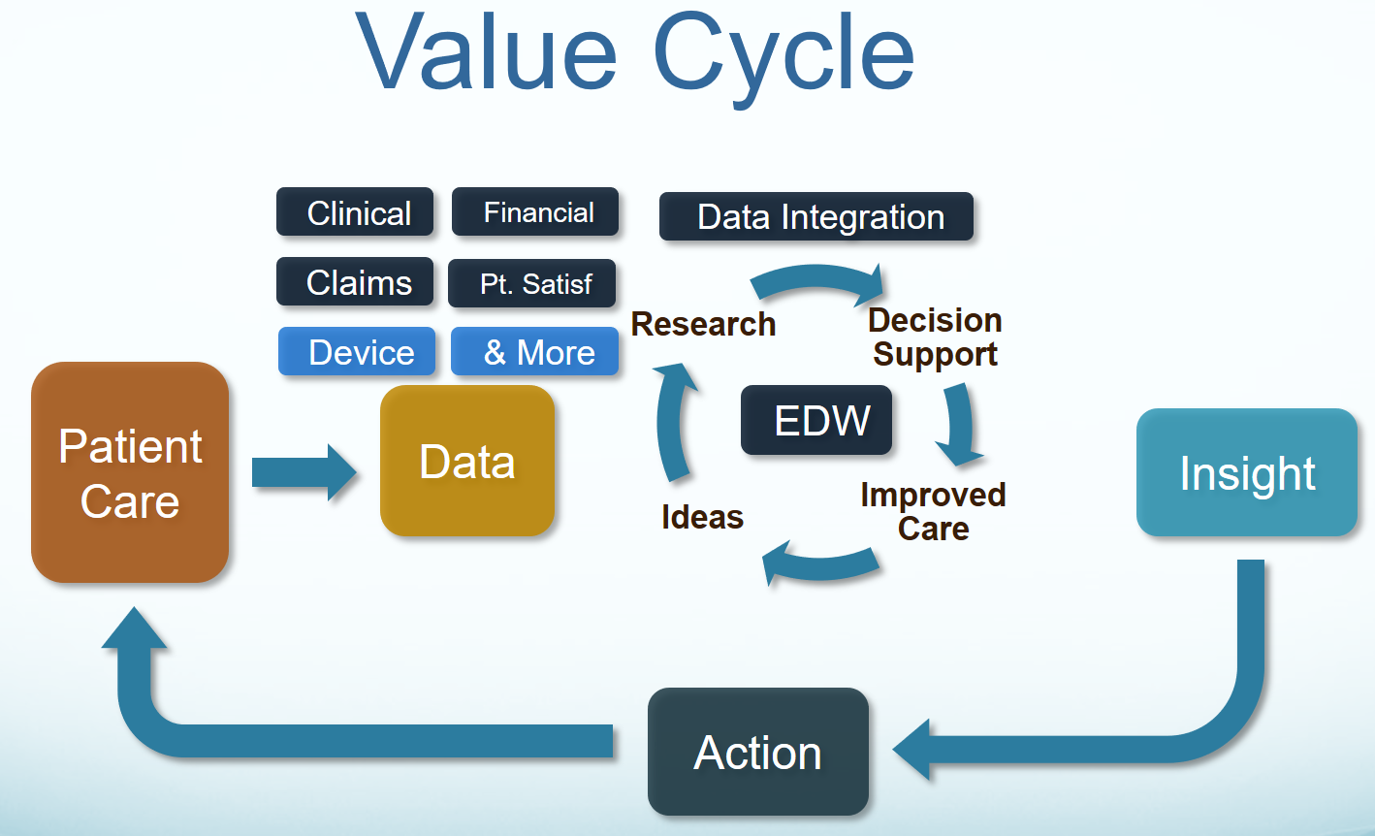

Figure 1 Computable interoperability value

Figure 1 Computable interoperability value shows that our patient care experience gives us a lot of data. - The data gives us an opportunity to take ideas and apply rigorous research. Research validates the ideas, which are then applied with confidence to improve patient care. This helps us make better decisions…not just in the future, but starting today. The Electronic Data Warehouse (**EDW**) is key in spinning this cycle faster to gain the insight necessary to decisively act, so we can improve the quality of care for our patients.

* 1. **The Problem** is that today’s systems do not capture the same information in the same way, and consequently, cannot easily share information or merge information from different sources to create a harmonized operational-picture of a patient across multiple care locations and contexts.

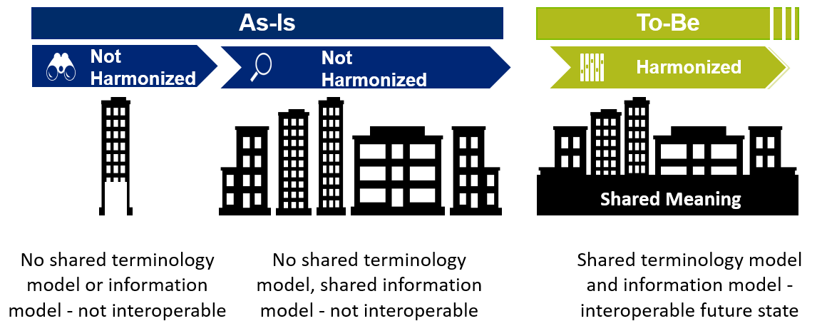

Figure 2 Skyscraper Interoperability Analogy

* 1. **Current State**: As represented in Figure 2 Skyscraper Interoperability Analogy, there is no shared terminology content (floor 1) and no shared information models (floor 2); where, implementation developments are building from the 3rd floor up; and where, there is little or no shared interoperability value from the 3rd floor up.  Each EHR vendor uses a proprietary database schema, proprietary models and unique terminology to represent clinical data. Some standardization of codes is now occurring, but Data is not consistent vendor to vendor, or even organization to organization within the same vendor. This means that:
     1. Sharing data is difficult
     2. Sharing executable software across vendors is impossible
     3. Each useful application is created or re-created on each different platform
  2. **Mapping alone does not work**: Even the best of implementation accelerators, like FHIR with its extensions and profiles, allow far too much implementation variation; where, each project often creates, from scratch, yet, another information model, e.g. through a mapping exercise. This is the “Models/Standards, Models/Standards Everywhere Conundrum”. The missed opportunity is to leverage a shared CLIM minimizing duplicative-work, avoiding inconsistencies and avoiding the necessity to engage these SMEs, these resources and our larger community. As an example, the “How CIMI can Help FHIR” (below) can address these sample FHIR issues:
     + 1. Standards use different formats and rules for ‘simple’ things like: name, address, dates or gender. Resulting in EHR-systems that after decades cannot uniformly exchange this ‘simple’ ubiquitous data; let alone ‘complex’ clinical health data.
       2. the HL7 EHR Interoperability workgroup, in its analysis of “Record Entry Lifecycle Event Metadata using FHIR,” found substantial provenance (who, what, when, where and how) inconsistencies among FHIR resources[4].
       3. The SOLOR and LEGO team found FHIR tries to define things such as attributes for anatomy, that are not based on a particular model of anatomy, and thus you get semantic overlap, with the burden of reconciliation, which may not even be possible, if left to the end user[5].
  3. **Recommended Future State**: We recommend shared and harmonized terminology content (floor 1), shared and harmonized information models (floor 2) and sharable computable interoperability value built on floors above for implementation developers and clinical users.
  4. **Recommended Technical Solution:** A CLIM & EHRS FM Reference Object Model (**ROM**)
     1. Recommended Technical Goal is computable interoperability from “Information Model Integration”; where, reference logical models make FHIR, CDA/CCDA, NIEM, and XML/JSON APIs and Clinical Decision Support (**CDS**) consistent and traceable.
     2. CLIM is HL7/ISO balloted, CIMI-workgroup curated and CIMI-compliant Common Logical Information Model (**CLIM**); and where, CLIM is the set of harmonized {SOLOR Terminology Foundational Model, FHIM Domain classes and attributes, CQF {DAF, QICore, KNARTs, eCQMs}, CIMI DCMs};
     3. HL7/ISO EHR System Functional Model (**EHRS FM**[6]) functions, use-cases, conformance criteria mapped to CLIM = Healthcare Domain Analysis Model (**DAM**).
     4. Tools seamlessly support software lifecycle developments and implementations.
     5. Help make FHIR profiles and extensions consistent.
  5. **How CIMI can help FHIR** with A CIMI curated CLIM:
     1. Seamless FHIR model driven architectural approach and tools, resulting from CIMI Reference Model’s patterns and Semantic Anchors converge on the FHIR core; where, tools can generate FHIR profiles and extensions from the CIMI’s semantic anchors for CIMI DCMs and CQF KNARTs and eCQMs etc.
     2. SOLOR Semantic bindings for FHIR structural elements providing consistent concept definitions and a clean separation of model semantics.
     3. identifying where various FHIR resources, such as Observation, DiagnosticReport and related profiles actually refer to the same thing (e.g., a lab result, a physical exam finding resources).
  6. **Our technical focus** is “Information Modeling: Foundation to Semantic Interoperability”; where, we collectively believe 1) the integrated CIMI-FHIM-SOLOR-CQF model “stack” is the basic foundation and 2) this stable foundation’s reuse is profoundly essential for seamless computable semantic-interoperability e.g., to ensure we don’t lose our way on the path-to “all-things FHIR”. Our subject matter experts are concentrating on the essential role that information models and associated tooling have in relation to computable semantic-interoperability, from a full software development lifecycle perspective. In this way, we are supporting key recommendations the Congress asked the HITPC[7] to make to the National Coordinator in 2015. Chief among these is that the federal government take a leadership role in defining the “right” approach to enable widespread interoperability in the near-term.
  7. **We present a technical path-forward** by weaving together many concurrent threads to create a widely-used foundational-and-reusable health information-model “stack” to empower future modeling and development efforts. This integration draws upon many existing efforts, and coordinates those efforts around a single, powerful goal of creating consistent logical-specifications for interoperable-implementations for the content of computable electronic health records, care plans, clinical knowledge and other shared healthcare information.
  8. **The modelling SMEs recommend**
     1. **Foundational Principles** as a starting point for federated development
        1. CIMI’s existing principles and modeling style guidelines[8].
        2. The modeling SMEs recommend adding the following foundational principles:
           1. A clean separation of clinical model semantics
           2. Using SOLOR (SNOMED with LOINC and RxNorm extensions); where, SOLOR supports organization extensions
     2. **An information model “stack”** be a CIMI curated (or similar entity curated[9]) HL7/ISO Common Logical Information Model (CLIM) standard, based on the integrated CIMI-FHIM-SOLOR-CQF; where, CLIM is a coined term for the collection of independently-created consistent-models harmonized by the CIMI principles.
        1. **This integration approach** harmonizes clinical practice needs with domain requirements models, clinical ontologies, medical vocabularies and existing healthcare information standards.
        2. **Interoperability barriers** include intentional information blockage, privacy and security, workflow and other organizational issues. Achieving a basic level of computability across healthcare systems—defined by the HITPC as the ability of a receiving system to understand the meaning of data transmitted—has been frustratingly difficult. Agreeing on universal adoption of standards-based EHR systems (and requiring certification) was considered key, but at a more foundational level, we now recognize that we must agree on these common, non-overlapping, but, connected logical-and-physical clinical information models to enable computable-interpretability among systems; where, tools can transform the logical to physical models and vice-versa. We are addressing this issue front-and-center to make this goal a reality.
     3. **SMEs should contribute in the building and sustainment of a Strategic Interoperability Plan** illustrating what optimum interoperability looks and feels via the establishment of the Information Modeling Foundation.  Point out federated near term (1-3 year plan), mid (3-5 year plan; 5-10 year plan) and long tern 10-15 and beyond) efforts that get us there. Each year assess progress against plan and as needed de-plan based on what's learned and then re-plan based on those yearly assessments.
     4. **We should next collaborate to construct a non-overlapping work-plan** for autonomous governance-and-program-execution; where, we can independently build non-overlapping models for computably-interoperable implementations, harmonized by the foundational principles, which were vetted and approved by the HL7 CIMI workgroup. The September final report adds the August meeting’s observations, recommendations and challenges in preparation to develop a 2017 HL7 Project Scope Statement (**PSS**) project plan and work breakdown structure for CIMI workgroup vetting and approval at the September HL7 meeting followed by Federal Partners, ONC and HL7 management vetting and approval before the January HL7 meeting.
     5. **Recommended Perfect-World-Approach**, concurrently and collaboratively do:
        1. “Federated Governance and Configuration Management”[10] for the CIMI curated and HL7 balloted Common Logical Information Model (**CLIM**) = SOLOR+FHIM+CIMI+CQF CIMI-compliant models.
        2. We integrate SOLOR into FHIM, while concurrently resolving SOLAR gaps
        3. We integrate CIMI, FHIM and CQF models
        4. We harmonize with analogous ISO models
        5. We follow Agile refinement cycles through pilots and implementations
        6. For full software development lifecycle (**SDLC**) support to model developers and implementers, we maintain open-source “*CIMI Practitioners’ Guide*”, test cases, test fixtures and supporting resources, such as reference implementations and virtual machine test environments.
     6. **Recommended Real-World-Approach**, we are recommending that:
        1. the Federal Partners provide resources to make efficient and effective progress in the near, mid and long term.
        2. the Federal Partners work together to maintain and use—in an ongoing way—a single integrated terminology system (SOLOR), that meets all US regulatory requirements, while simplifying implementations for developers.
        3. the FHA facilitate Federal Partner governance and their configuration management, “*CIMI Practitioners’ Guide*”, test cases, test fixtures and supporting resources, such as reference implementations and virtual machine test environments.
        4. The ONC OST endorse this initiative and facilitate resources
           1. ONC Tech Lab
           2. Jump start all initiatives with the recommended formal models and an MDA approach.
           3. Implementation and demonstration pilots via HSPC, Argonauts, etc.
           4. Consideration to stand up Technical Learning Community (TLC) governance - organizations are able to participate with ONC in a formative way, participating in developing a policy and approach, rather than only having input later in the “request for comments” phase.
        5. The IPO provide coordination and facilitation
           1. Use HL7 CLIM=SOLOR+FHIM+CIMI+CQF on DoD & VA initiatives.
           2. Leverage JIF funds for Implementation demonstration pilots and “*CIMI Practitioners’ Guide*”, test cases, test fixtures and supporting resources, such as reference implementations and virtual machine test environments.
     7. HL7 facilitate
        1. International, commercial and academic peer review,
        2. Harmonization with analogous ISO standards[11],
        3. Ballot governance and configuration management and
        4. Coordination of an HL7 and ISO ballot (ISO will be several years from now)

## Recommended Pilot Project Path

* 1. Advance CLIM forward through pilots and agile development
     1. Identify the Project with willing parties that will implement the outputs for the Project
     2. Identify the data elements needed to support the project
     3. Identify the FHIM classes that support the data elements
     4. Approve the CLIM approach
     5. Place CLIM in a registry that is publicly available
     6. Create FHIR profiles and extensions using SIGG=MDHT+MDMI
     7. Make the application via use of FHIR Profiles and extensions
     8. Test the application for compliance with the models and standards
     9. Put the application in production use & evaluate CLIM + SIGG value
     10. **Repository & Registry**: Make the Detailed Clinical Models based on CLIM=SOLOR+FHIM+CIMI+CQF publicly available
     11. **General**: Make project people available and EHR available for testing
     12. **Parallel Activities**, based on lessons learned:
         1. Install a public SOLOR Terminology Server;
         2. Harmonize models
         3. Harmonize SOLOR, FHIM, CQF, CIMI and SIGG tools to seamlessly support CLIM developers and system interoperability implementers.
  2. It is considered essential to begin proceeding in an agile way with the intention to apply these steps against many pilots making model, methodology, test and documentation adjustments via lessons learned.

## Contributions by Resource

The term ‘interoperability’ can be challenging enough. In discussions of the CIMI-FHIM, it was noted that reverse-engineering FHIR implementations does not result in a consistent logical model; but rather, a harmonized FHIM-CIMI-SOLOR-CQF MDA in needed to get consistent FHIR profiles and extensions.

## Clinical Information Model Initiative (CIMI)

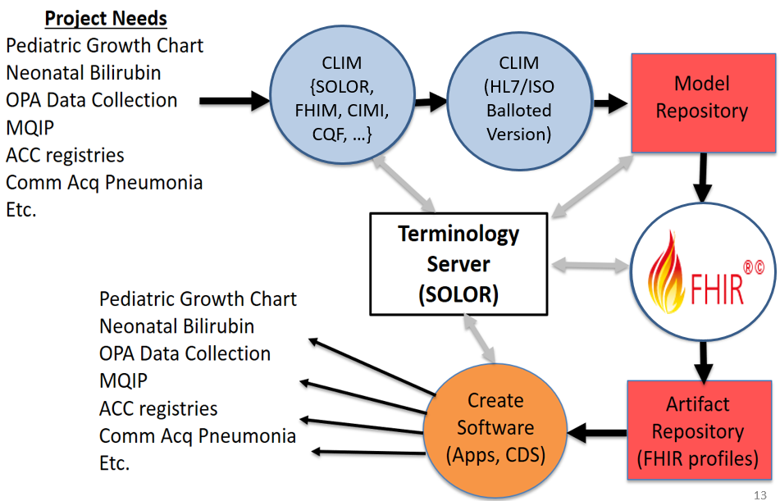

Figure 3 Applications based on integrated reusable-models

* + 1. The Clinical Information Modeling Initiative (**CIMI**) is a collaboration framework designed to provide a common format for representing common terminology in various areas and backgrounds. It relates to the FHIM, SOLOR, CQF and other initiatives. Additionally, CIMI connects to the processes, information models, and quality models as well as the terminology relates to detailed clinical models (**DCMs**).
    2. The *Figure 3 Applications based on integrated reusable-models* Interoperable App Development Process is designed to enable better patient care, by highlighting apps, registries, and clinical decision support components that should be included. The use of a logical model repository leads to the development of consistent physical artifacts, such as a FHIR profiles. Logical models can also be used for more than just data exchange and can be applied to clinical decision support and quality measures as well.
    3. CIMI is intended to be used to create a repository of clinical information models (DCMs, KNARTs, eCQMs, etc.). The base data types used are terminologies that are a part of SOLOR and relate to coded attributes. The CIMI models are independent of programming language and are considered platform-independent. The model development lifecycle includes specialization and localization to algorithmically implement different components.
    4. Current CIMI activities include collaborating with HSPC and developing tools, importing InterMountain DCMs, other organizations’ DCMs, CQF artefacts, creating FHIR dictionaries based on the models, and testing to ensure that software is compliant with the models.
    5. SOLOR provides the terminology foundation, FHIM provides the upper definition of objects; CQF provides the CDS and quality measures perspective, CIMI specializes the SOLOR-FHIM-CQF content into DCMs to be relevant to clinical use.
    6. A SOLOR terminology server serves as a repository for new CIMI content. SNOMED serves as a source of concepts for semantic buildings as well as inferences. The Lightweight Expression of Granular Objects (**LEGO**) model is separate from SOLOR but can also provide semantic model content and can be used to test the validity and consistency of models.

## Federal Health Information Model (FHIM)

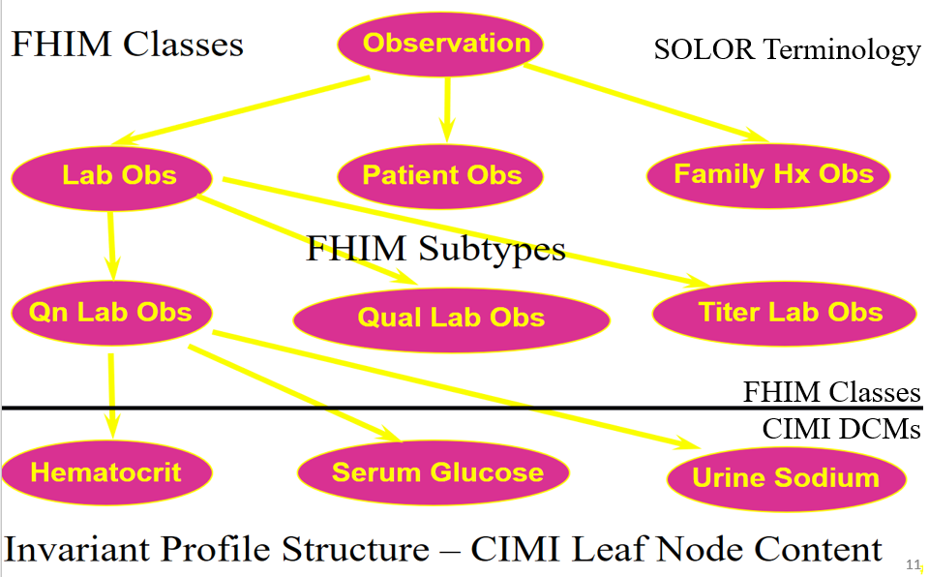

Figure 4 Clinical example of CIMI-FHIM integration

* + 1. As shown in *Figure 4 Clinical example of CIMI-FHIM integration*, SOLOR Terminology, FHIM domain classes and CIMI DCMs are symbiotic, resulting in a consistent conceptual-and-logical MDA model hierarchy, which can specify physical FHIR implementations.
    2. In 2009, an FHA project developed a set of core and basic models for developing a baseline for the FHIM, with inputs from National Cancer Institute (**NCI**), Food and Drug Administration (**FDA**), Veterans Administration (**VA**) and Centers for Disease Control and Prevention (**CDC**). The FHIM provides an ONC-supported forum for harmonizing US realm health data requirements, including legacy requirements (VistA, CHCS, AHLTA, Cerner) and prospective requirements by examining current standards efforts. FHIM is suitable for international use as well.
    3. The FHIM also uses Model Driven Health Tools (**MDHT**). The VA and ONC have previously supported MDHT and Model Driven Message Interoperability (**MDMI**) open-source projects encompassing many components driven with implementable artifacts. Ongoing collaboration and mapping contributes to the refactoring of FHIM. The FHIM provides the framework and information model for CQF and CIMI and can inform the creation of FHIR profiles.

## SNOMED, LOINC, RXNorm (SOLOR)

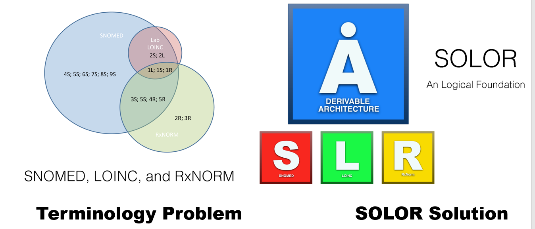

Figure 5 SOLOR with SNOMED extensions solve LOINC and RXNorm inconsistencies

* + 1. As shown in *Figure 5 SOLOR with SNOMED extensions solve LOINC and RXNorm inconsistencies*, SOLOR incorporates several terminology standards, including: SNOMED, RxNorm, and LOINC, into a logically integrated—and structurally normalized—foundation. Its benefits allow the structure to be normalized to improve software reuse. While the three standards cover different types of content, SOLOR harmonizes the overlap between them, lending to opportunities for greater interoperability between systems.
    2. SNOMED, LOINC, and RxNorm are Meaningful Use (**MU**) specified standards and are evolving. Recently, IHTSDO and the Regenstrief Institute reached a collaborative agreement where overlapping aspects of SNOMED CT and LOINC will be linked to facilitate interoperability[12].
    3. The SOLOR design incorporates a standard extension model drawn from SNOMED. However, different organizations can have specific extensions; for example, the VA has its own extension as does Kaiser Permanente.
    4. As the terminology landscape evolves, the standards organizations and terminology relationships have not changed as much. Generally, standards are built upon a common foundation that is needed for interoperability. Extensions can also enable dialect creation and knowledge bases. They also permit timely customizations to meet local needs, as in the case of the VA and Kaiser extensions.
    5. SOLOR is endorsed by the Health Services Platform Consortium (**HSPC**) as a terminology foundation for interoperable decision support[13]. Additional development and sandbox resources with SOLOR will also enable testing efforts.
    6. SOLOR is an ongoing project that continues to progress and evolve through the work of consensus activities. The primary principle of SOLOR centers around delivering content that provides for a separation of semantic meaning by developing a normalized structure. The basic features of this content can be delivered through a variety of terminology services, including FHIR terminology services, or CTS2. Advanced features of this content (dialect support, OWL DL EL profile support, incremental classification support) will require extensions to most terminology services.
    7. The current efforts between the DoD, VA, and IPO focus on mapping. While mapping serves a specific purpose, it will generally be a step behind the release process. Ideally, the DoD and VA would develop their Departmental SOLAR extensions and the IPO could help integrate the two.

## Clinical Quality Framework (CQF) and Standards Quality Improvement

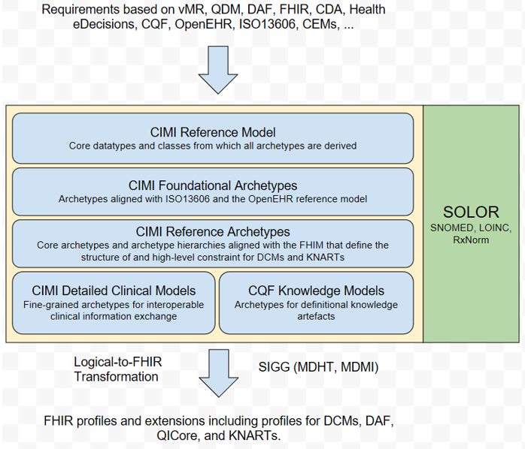

Figure 6 SOLAR, FHIM, QDF and CIMI integration producing consistent FHIR

* + 1. *Figure 6 SOLAR, FHIM, QDF and CIMI integration producing consistent FHIR* shows the SDLC process, supported by tooling, that can seamlessly supports venders, developers and implementers.
    2. The Clinical Quality Framework (**CQF**) is focused on harmonization as well as using a flexible and model-agnostic approach; where, standards harmonization, including this CLIM initiative, allows for the electronic representation of clinical decision support knowledge Artefacts (**KNARTs[14]**) and electronic Clinical Quality Measures (**eCQMs**); because, these standards were not developed in coordination with one another and used different approaches.
    3. There is extensive metadata used in KNARTs, requiring alignment with HL7 requirements. CQF adopts the approach of developing a more harmonized and aligned product to drive improvements in clinical care.
    4. The clinical quality language (**CQL**) is not FHIR-specific; but, it is used in FHIR broadly. CQF is more human-and-machine readable. Similarly, the Expression Logical Model is machine-friendly as well.
    5. CQF exemplifies progressive convergence for topics that may not necessarily generate consensus right away. In the case of CQF, the users start with the common challenges and time box it to bring in additional partners and expand the scope.
    6. Both the Data Access Framework (**DAF**) and CQF are both ONC-sponsored under the Standards & Interoperability (**S&I**) Framework. DAF has a slightly more limited scope than CQF but the DAF content has become a part of the Quality Improvement (**QI**) core. The QI Core has an implicit model behind it.
    7. There are a number of conformance problems and technical difficulties that emerge as we layer FHIR profiles and extensions. The unified clinical data model uses clinical workflows that require continual improvement as progress is made.

## Operational Architecture

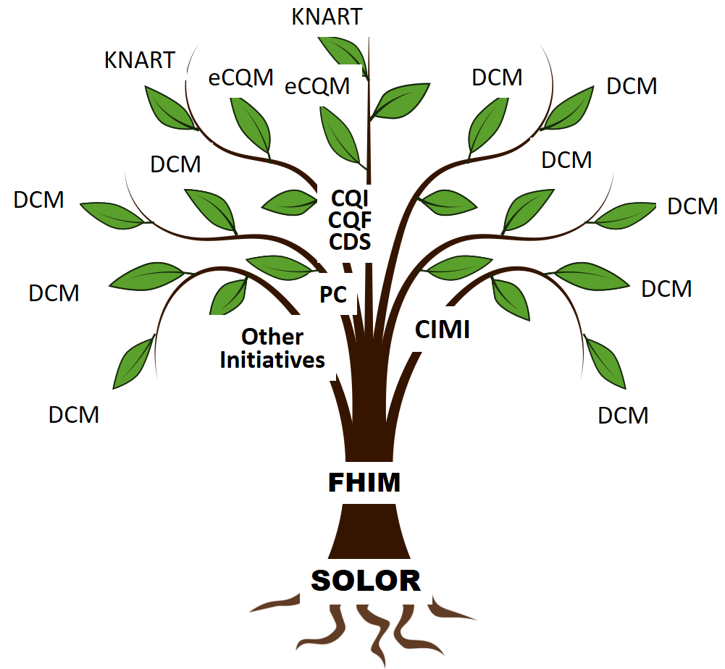

Figure 7 Each model contributes to an Integrated Model Stack

1. As shown in *Figure 7 Each model contributes to an Integrated Model Stack*, the proposed operational architecture involves the definition of clinical knowledge in the form of formally modeled information artifacts that could be used in compose-able health records, care plans and other shared clinical data. As represented in *Figure 7*, the combination of SOLOR, FHIM, CIMI and CQF while complementary fulfill a different information modeling contribution. Each information artifact is defined with an unambiguous and computable meaning, employs a specific, shared vocabulary, and has a specific information structure and terminology binding. Going from conceptual to an operational perspective, we get the *Figure 8 MDA’s vision seamlessly supports developers and implementers*.

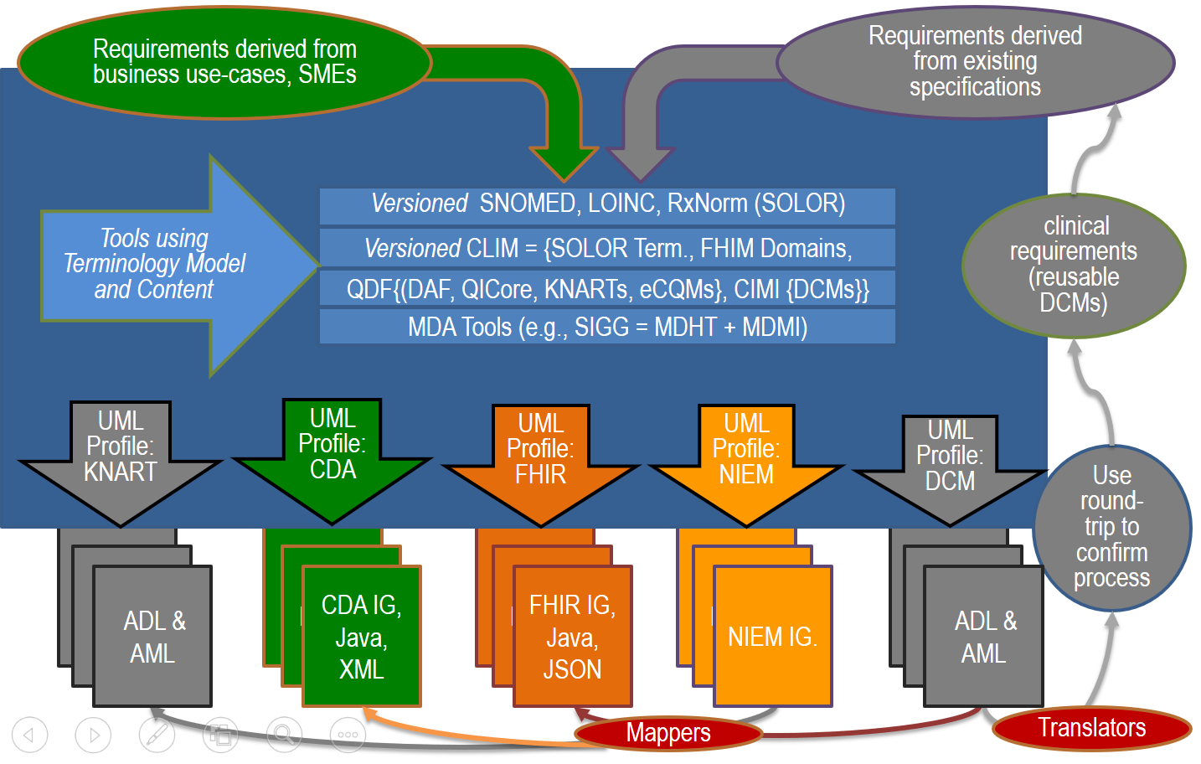

Figure 8 MDA’s vision seamlessly supports developers and implementers

1. Model Driven Healthcare Tools (**MDHT**) and Model Driven Message Interface (**MDMI**) are complementary Model Driven Architecture (**MDA**) tooling projects, based on Object Management Group (**OMG**) standards, that deliver the capability for a Semantic Interoperability Guide Generator (**SIGG**). MDHT is an open source project at Eclipse.org that supports a full development lifecycle using the Unified Modeling Language (UML) for model design, transformation between alternative model representations, Java code generation, and testing/validation of instance data. MDMI open-source tools define and leverage a shared dictionary of semantic business artifacts that are assigned to model artifacts in various logical and implementation models for healthcare data, including FHIM, C-CDA, FHIR, and others. MDMI + MDHT enables automated generation of Traceability and Gap Analysis reports between any of the mapped models, plus generation of target model profiles for the identified gaps, e.g. FHIR profiles. MDMI tools also include a runtime platform for transforming mapped instances of healthcare data, e.g. C-CDA documents to FHIR resources.
2. **The key challenges** are:
   * 1. This effort draws upon many existing efforts, and must coordinate these efforts around a single, powerful goal of creating standards for the clinical knowledge content of an electronic health record, care plans and shared data.
     2. It will require combining clinical practice needs with domain modeling, ontologies, medical vocabularies, and information modeling, leveraging existing healthcare information standards.
     3. Federated implementation of the path forward for health information and interoperability, weaving together many concurrent threads by creating shared principles and a common target for future modeling and development efforts.
     4. Maintaining seamless Model Driven Architecture (MDA) tooling

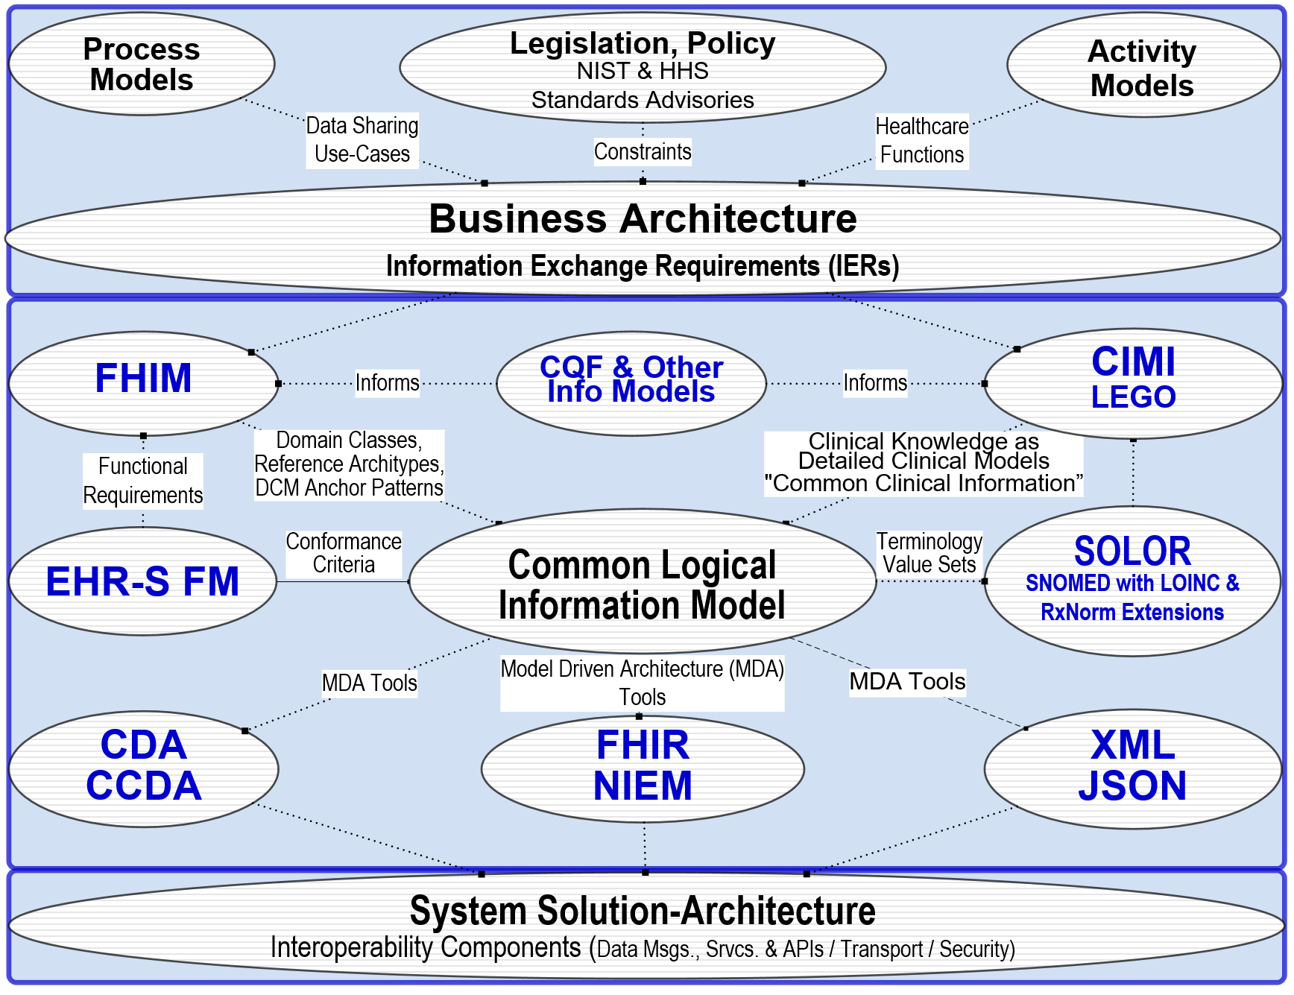

Figure 9 High Level Architectural View

1. **Operational Solution Architecture**: As shown in *Figure 9 High Level Architectural View*, the integrated SOLOR-FHIM-CIMI-CQF models are a set of Common Logical Information Models (**CLIM**) designed to be used in Model Driven Architecture (**MDA**) solution architecture specifications for implementations, which require configuration management and governance. The integrated approach is traceable to the business architecture, which is designed to generate consensus for consolidation and CLIM development as a basis for interoperability. Interoperability can be considered as a workflow, that goes across organization boundaries.
2. It should be noted that FHIR is a specific point of reference, as models often have to live on past the initial iteration of a standard. As FHIR becomes outdated, the model must continue onto the next ‘hot standard.’
3. The HSPC is an example of platform-based ecosystem with software and standards-based services. MDA that clinical questions can be answered by these models and the metrics for the value of interoperability include the value to remove duplicate or wasteful work by reuse of these models within an MDA; where, the primary motivation for these frameworks is to improve social agreement on a technical interoperability approach as an essential step towards achieving these goals.

## Way Forward Attributes of Success

* 1. Increased awareness related to Information Modeling, Tooling and Integration effort
  2. Advocacy (via Communications Plan / Governance / Strategic Interoperability Plan) to insert routinely and jump start with (formal) information Modeling Assets into projects and standards development efforts
  3. Advocacy to support follow-on efforts and implementation practicality
     1. Sustain Core SME collaboration to refine integration recommendations
     2. Expand and invest in building upon current SME base
     3. Apply insights and recommendations into the “*CIMI Practitioners’ Guide*”
     4. Build out near-term, mid-term and long-term efforts via work breakdowns
     5. Assess and layout resourcing implications tied to recommended efforts
     6. Capitalize on follow up Modeling Meeting with FHIR colleagues and establish a Process Engagement Strategy
     7. Submit final report and PSS during Sep 2016 HL7 CIMI Workgroup
     8. Sustain predictable stakeholder contact and forums
  4. Supportive of Integration
     1. To get underway in the near-term, repurpose or reprioritize current efforts to build models with active engagements
     2. Advance information modeling resources via pilots that offer gains while applying lessons learned in support; enhance usability interests
     3. Acknowledge and enhance SME base, User Community Partnerships and Stakeholder Community Contacts to guide a shifting in commitments opening up the ability to focus on this Bigger Picture to serve as an underlying interoperability strategy

## Initial Work Breakdown Structure (see MS Project version at end for details)

* 1. High level work breakdown areas include:
     1. Governance
     2. Pilot Project Selection and Development
     3. Communication
  2. Continued legacy mapping makes sense in the short term. The Model Driven Architecture (**MDA**) makes sense in recommended long-term future-state and beyond; and a hybrid transition strategy makes sense in the mid-term.
  3. Our five objectives must be the central focus of the WBS:
     1. Accept (Formal) Information models as the Foundation for interoperability
        1. Use CIMI and FHIM while all evolve via the integration work
     2. Pursue the Integration of harmonized models as the Enabling Foundation to jump start initiatives
        1. CLIM=SOLOR+FHIM+CIMI DCMs+CQF KNARTs 🡪 FHIR, CCDA, NIEM etc.
        2. Others: DAF, SDC, etc.
     3. Integrate tooling to support models to extend the utility of these assets
     4. Use models and tools to generate standards and implementation artifacts
     5. Advance in constructive steps through pilots and agile development
        1. Skin Assessment / ADL / PC Wound Care
        2. Document Types discordance between DoD and VA
        3. Plan of Care Order Transcription / Resulting challenges
        4. ACOG “Data Elements”
        5. CQF – FHIR – Argonaut opportunities
        6. IPO-sponsored FHIR JET using MDHT / MDMI
        7. DoD/VA Health Data Sharing Business Line Workgroups (Population Health)
        8. Explore use of FHIM to support EHR System Functional Model

## Stakeholders: Collaboration that Grows with Strong SME Base

* 1. CIMI Co-Chairs
     1. Linda Bird BIT, IHTSDO
     2. Galen Mulrooney, FHA and VA
     3. Harold Solbrig, Mayo Clinic
     4. Stanley Huff, Intermountain Healthcare
  2. Members of the following SDOs
     1. IHTSDO, POC: Linda Bird BIT
     2. HL7 Work Groups (PC, CDS, CIC, EHR, SOA, Vocab)
     3. The Open Group Healthcare Forum, Jason Lee POC
     4. ISO and CEN, POCs: Gerard Freriks, William Goossen, Gary Dickinson
  3. Federal Agency staff and contractors
     1. Department of Defense
     2. Veterans Administration
     3. Interagency Program Office
     4. ONC OST and its Federal Health Architecture
  4. Members of the following Healthcare Organizations
     1. Intermountain Healthcare
     2. PenRad, Inc., Results4Care
     3. HSPC and other interested parties
  5. Faculty, Staff and students
     1. The University of Utah

## Index of Acronyms

AHLTA, 11

Argonauts, 8

CCDA, 5, 18

C-CDA, 16

CDA, 5

**CDC**, 11

**CDS**, 5, 10, 19

Cerner, 11

CHCS, 11

CIC, 19

CIMI, 1, 2, 3, 5, 6, 7, 8, 9, 10, 11, 13, 15, 17, 18, 19, 23

CLIM, 1, 2, 5, 6, 7, 8, 9, 13, 17, 18, 23

CQF, 1, 2, 5, 6, 8, 9, 10, 11, 13, 14, 15, 17, 18, 19, 23

**CQL**, 14

**DAF**, 14, 18

**DAM**, 6

**DCM**, 1, 3, 14

DCMs, 1, 5, 6, 9, 10, 11, 14, 18

DL, 13

**eCQM**, 1

eCQMs, 1, 5, 6, 10, 14

**EDW**, 4

EHR, 4, 5, 6, 7, 9, 19

EHRS FM, 5, 6

EL, 13

**FDA**, 11

FHA, 8, 11, 19

FHIM, 1, 2, 3, 5, 6, 7, 8, 9, 10, 11, 13, 15, 16, 17, 18, 19, 23

FHIR, 2, 3, 5, 6, 9, 10, 11, 13, 14, 16, 17, 18, 19, 23

HITPC, 6, 7

HL7, 1, 2, 5, 7, 8, 9, 14, 18, 19

HSPC, 8, 10, 12, 17, 19

IPO, 8, 13, 19, 23

ISO, 2, 3, 7, 8, 9, 19

JIF, 9, 19

JSON, 5

**KNART**, 1, 5, 14

KNARTs, 1, 5, 6, 10, 14, 18

LEGO, 5, 11

LOINC, 3, 7, 12

MDA, 8, 9, 11, 15, 16, 17, 18

MDHT, 9, 11, 16, 19

MDMI, 9, 11, 16

**MU**, 12

**NCI**, 11

NIEM, 5, 18

ONC, 8, 11, 14, 19

OTS, 8, 19

OWL, 13

PC, 19

PSS, 8

**ROM**, 5

RxNorm, 3, 7, 12

SIAMM, 9

SIGG, 9

SME, 1, 18, 19

SMEs, 1, 3, 5, 7

SNOMED, 3, 7, 11, 12

SOA, 19

SOLOR, 1, 2, 3, 5, 6, 7, 8, 9, 10, 11, 12, 15, 17, 18, 23

TLC, 8

VA, 9, 11, 12, 13, 19

VistA, 11

Vocab, 19

WBS, 1, 18, 21, 23

XML, 5

## Work Breakdown Structure (WBS)

## This DRAFT WBS is under development.

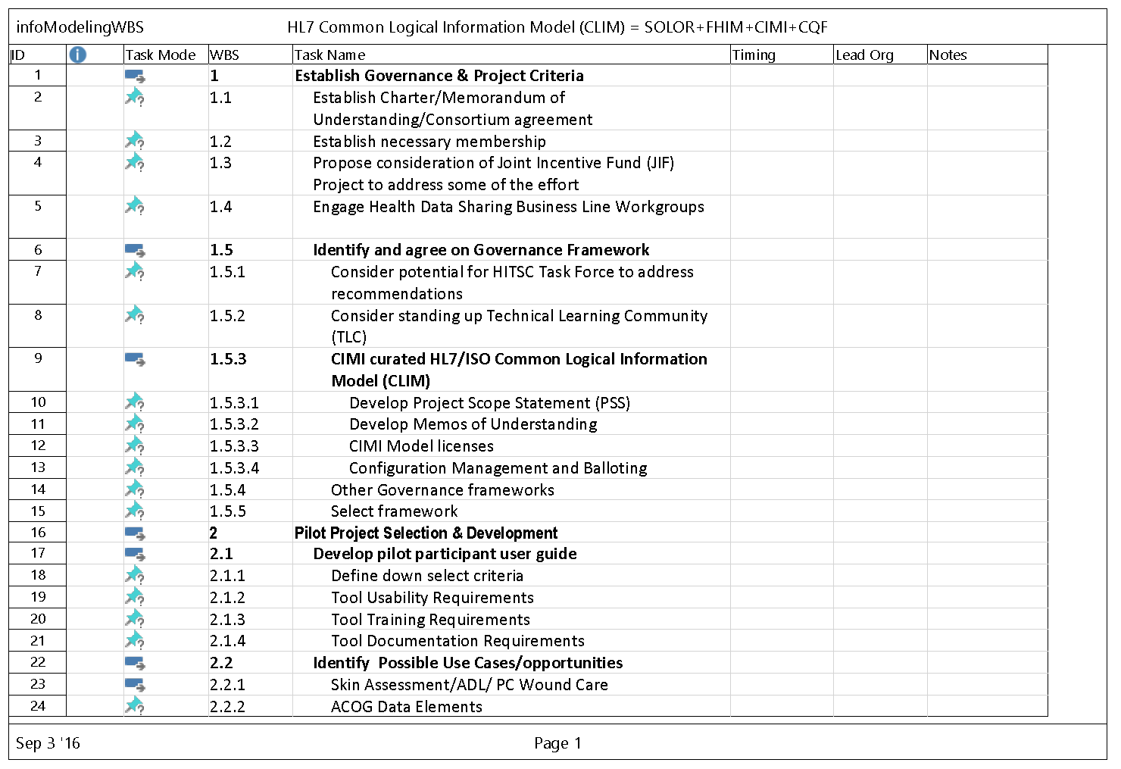

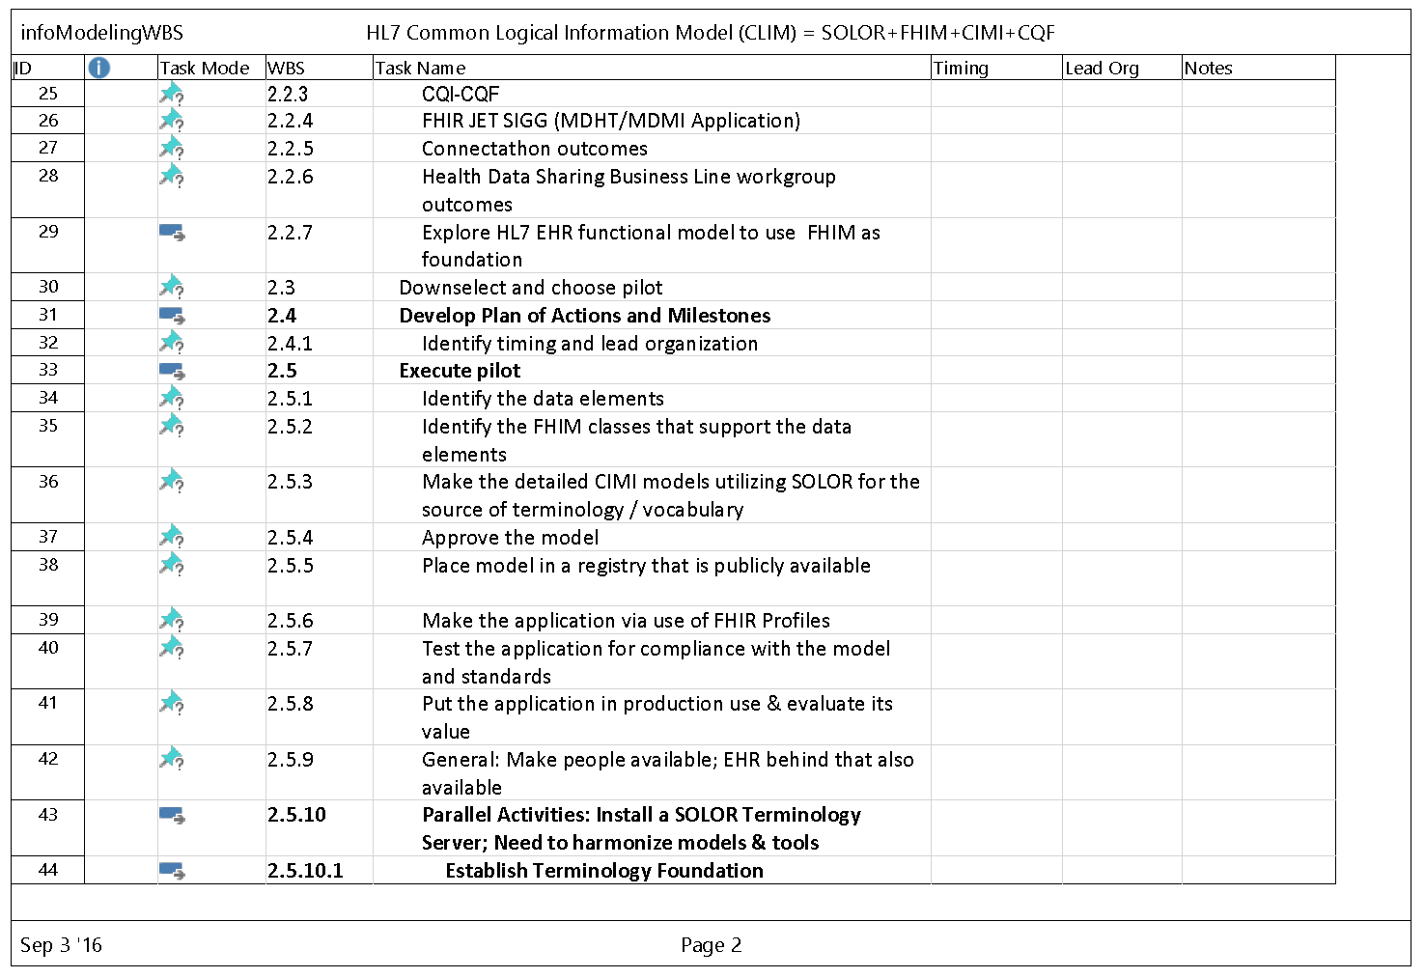

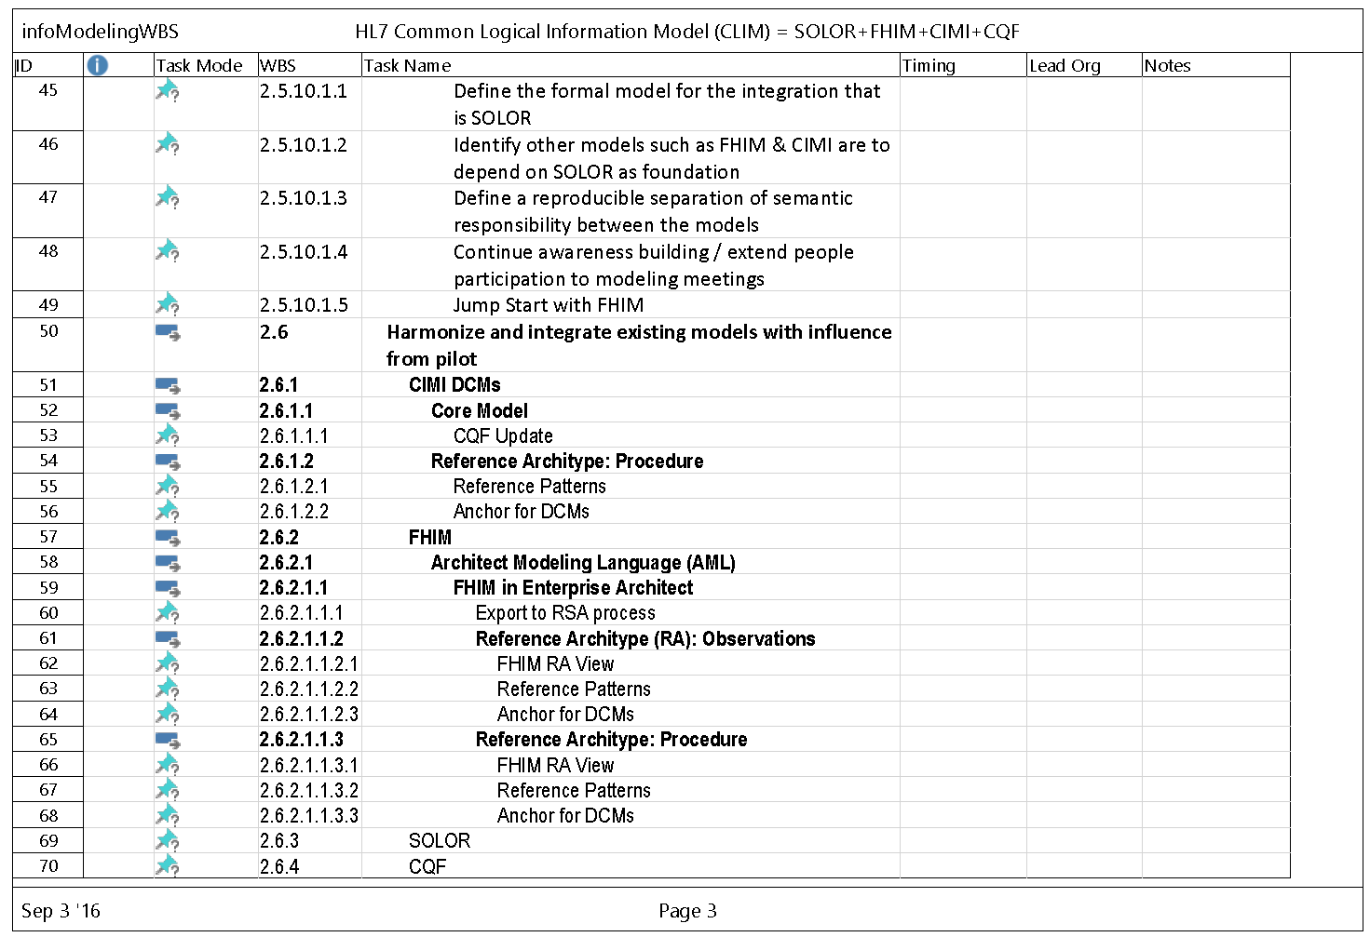

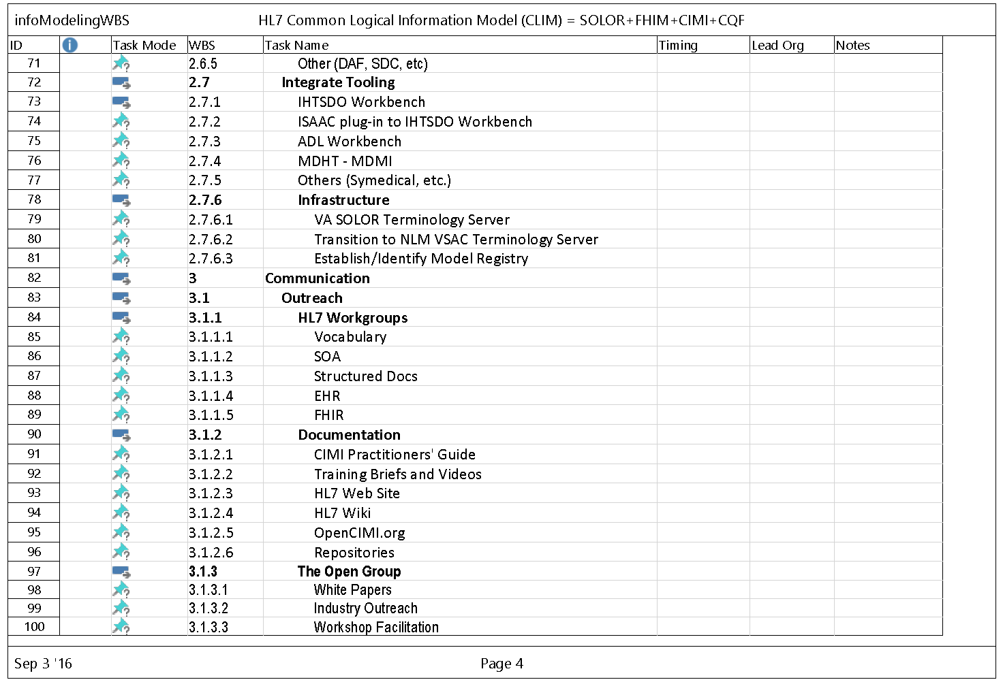

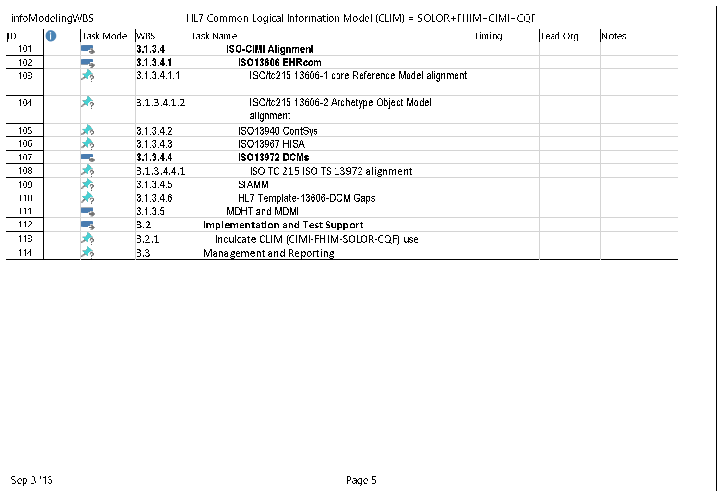

**This DRAFT WBS is under development, such as:**

* Upgrade CTS2 at HL7 to support REST sets needed for SOLOR extensions.
* Harmonize SOLOR, FHIM, CQF, CIMI and SIGG tools to seamlessly support CLIM developers and system interoperability implementers.
* Harmonize US models with equivalent ISO models
* How CIMI can make FHIR better recommendations
* **Picking a Project / Corresponding Criteria** (add ones from Steve K)
  + CQF – FHIR – Argonaut opportunities
  + Leverage Joint Incentive Fund (JIF) Project as means to address effort
  + Engage Health Data Sharing Business Line Workgroups
  + Consider potential for HITSC Task Force / ONC Technical Learning Community
  + Create a FHIR profile
  + Evaluate Usability, Training, Outreach Documentation & Opportunities
  + DaVinci at IPO
  + ACOG
  + Skin Assessment
  + Radiology Orders & Results transcription
* Communication Outreach: What efforts should occur; who should be briefed in order to shift the narrow ‘here and now’ focus to this ‘bigger picture’.
  + DoD/VA IPO, OST & FHA Sr Leadership Staff
  + DHMS, Ms Cummings
  + CIOs / Sr VIPs in DoD and VA perhaps the HEC (Health Exec Council) or even JEC (Joint Exec Council)
  + HHS / ONC Leadership: Dr Washington/Dr White
  + DoD/VA HDS Bus Line Groups (Pop Health)
  + ICIB (Interoperability Clinical Informatics Board

1. Information Model Integration = HL7 CLIM = {SOLOR Terminology, FHIM domain classes, CQF {DAC, QICore, KNARTs, eCQMs}, CIMI DCMs}; where **DCM** is Detailed Clinical Model, **KNART** is knowledge artifact, **eCQM** is Meaningful Use indicator
2. discussed in Preliminary Report
3. See “CIMI Practitioners’ Guide to HIE Interoperability” at [https: and and 1drv.ms and w and s!AlkpZJej6nh_k6ZUeG7W6TaWcbTZ4Q](https://1drv.ms/w/s!AlkpZJej6nh_k6ZUeG7W6TaWcbTZ4Q)
4. as discussed in Preliminary Report also see

   FHIR W5 (who, what, when, where, why) Report for STU-3: <http://hl7.org/fhir/2016Sep/w5.html>

   FHIR STU-3 EHR-S Record Lifecycle Event Implementation Guide: <http://hl7.org/fhir/2016Sep/ehrsrle/ehrsrle.html>

   FHIR STU-3 RLE AuditEvent Profile: <http://hl7.org/fhir/2016Sep/ehrsrle/auditevent-ehrsrle.html>

   FHIR STU-3 RLE Provenance Profile: <http://hl7.org/fhir/2016Sep/ehrsrle/provenance-ehrsrle.html>
5. discussed in the footnote of Preliminary Report Section
6. ISO/HL7 10781 EHRS FM Release 2: <http://www.hl7.org/iOSement/standards/product_brief.cfm?product_id=269>
7. Several Health IT Policy Committee (HITPC) workgroups have been formed as subcommittees to the parent FACA (Federal Advisory Committee Act (FACA). These workgroups meet periodically to discuss their topics, present their findings at Health IT Policy Committee meetings, and make recommendations to the Health IT Policy Committee.

   The Health IT Policy Committee workgroups are:

   * [Advanced Health Models and Meaningful Use](https://www.healthit.gov/facas/FACAS/health-it-policy-committee/hitpc-workgroups/advanced-health-models-and-meaningful-use-workgroup)
   * [Consumer](https://www.healthit.gov/facas/FACAS/health-it-policy-committee/hitpc-workgroups/consumer-workgroup)
   * [Interoperability and Health Information Exchange](https://www.healthit.gov/facas/FACAS/health-it-policy-committee/hitpc-workgroups/interoperability-and-health-information-exchange)
   * [Privacy and Security](https://www.healthit.gov/facas/FACAS/health-it-policy-committee/hitpc-workgroups/privacy-and-security-workgroup)

  
8. See “CIMI Practitioners’ Guide to HIE Interoperability” at [https: and and 1drv.ms and w and s!AlkpZJej6nh_k6ZUeG7W6TaWcbTZ4Q](https://1drv.ms/w/s!AlkpZJej6nh_k6ZUeG7W6TaWcbTZ4Q)
9. Curation involves governance and configuration management (CM) and is hierarchical; that is, curation is done by independent organizations developing models and there also is the curation at HL7 to govern and configuration-manage the CLIM (set of CIMI compliant models) for periotic HL7 and/or ISO balloting and versioning, such as for Draft Standards for Trial Use or normative standards. CIMI curation involves two classes of models preferred and non-preferred styles-of-modeling; where preferred models conform to the CIMI Principles (e.g., Terms of Reference in this report’s appendix E); and where, non-preferred models are iso-semantic with preferred CIMI models; where ideally, these models can be round-trip transformable by a tool.
10. Federated governance and configuration management (CM) AKA curation is hierarchical; that is, governance and CM are done both by the independent organizations developing models and by CIMI’s curation of the periodic HL7 and ISO balloting and versioning of the CLIM (set of CIMI compliant models). CIMI curation involves two classes of models preferred and non-preferred styles-of-modeling; where preferred models conform to the CIMI Principles (e.g., Terms of Reference); and where, non-preferred models are iso-semantic with preferred CIMI models; and where ideally, these models can be round-trip transformable by a tool.
11. The following ISO standards have been identified as impacting this recommended initiative and should be harmonized

    ISO/tc215 and CEN/tc251 Concurrent Use

    ISO EN 13606 1-5 (EHRcom)

    ISO EN 12967 (HISA)

    ISO EN 13940 (ContSys)

    ISO TS 13972 (DCMs)

    SIAMM (Internal Document)
12. <https://loinc.org/news/regenstrief-ihtsdo-agreement-to-make-emrs-more-effective.html> 
13. <http://www.businesswire.com/news/home/20160719005555/en/Healthcare-Services-Platform-Consortium-Launches-Data-Standard-Integration>
14. A **KNART** is a Knowledge Artifact representing clinical knowledge; where, a **DCM** is a Detailed Clinical Model representing a specific fact or statement about a patient.